DTP Capitalisation Strategy
Thematic Poles 1, 2 and 3
TP1: Innovative Ecosystems for SMEs
TP2: RDI framework support
TP3: Entrepreneurial Learning Systems

Meeting of poles 1, 2 and 3
October 17th 2017, Budapest

14:00 h | Welcome Annamária Oláh, CCIB Budapest
14:10 h | Short presentation of participants and projects  - DTP – Marius Niculae – Project Officer, DTP Joint Secretariat - expectations from capitalization activity (5 Min)  - EUSDR Priority Area 8 – Dragica Karajić and Dr. Susanne Ast (10 Min)  - Pole 2 Coordinator – Dr. Ines Marinkovic, Center for Social Innovation - capitalization activities in Pole 2 (10 Min)  - Pole 3 Coordinator - Mária Baracsi, IFKA Public Benefit Non-Profit Ltd. for the Development of the Industry - capitalization activities in Pole 3 (10 Min)  - Project coordinators (30 Minutes; aprox. 3 Min/Project)
15:10 h  16:00 h | Working together Pole1, Pole 2, Pole 3 and Priority Area 8 Competitiveness  Break
16:15 h | Projects Thematic fields – working together at the project level – cross-cutting issues  Roadmap Pole 1
17:00 h | 6th Annual Danube Forum – Workshop DTP Capitalisation
17:45 h | Conclusions
18:00 h | End of Meeting
Agenda:

Venue:
Chamber of Commerce Budapest (CCIB)
1016 Budapest, Krisztina körút 99.

Meeting minutes:
- DTP puts emphasis on the importance of the capitalization strategy which should improve results of projects, create basis for future partnerships, and enable broader reach of stakeholders.
- Interreg projects connected to MRS may create better political awareness, have better leverage effect, and contribute to closure of the knowledge gap. The cooperation and use of MRS may be established through pole activities and networks.
- The capitalization strategy of DTP projects should focus on horizontal contribution and find horizontal synergies, meaning all thematic poles may and should contribute to all priority areas: PA7, PA 8, PA9.
- Options to put together outputs of projects were discussed, including proposal of developing common deliverables such as joint thematic studies or joint thematic study exchanges. Follow up on this issue is needed by JS whether it is possible to report joint deliverables in eMS as well as how to handle budget leftover if it occurs (e.g. in case duplicity in deliverables occurs).
- The first results of capitalization are expected next year (2018)
- Pole 2 leader suggested a stronger involvement of all project partners of participating projects from pole 1, 2 and 3 in capitalisation activities based on specific / more detailed topics and not exclusively within only one thematic pole. Further discussions on this issue and the joint strategy are necessary among pole 1, 2 and 3 leaders.
- During the meeting, pole leaders presented their poles and roadmaps, workshops for the EUSDR forum were discussed, and representatives of projects of pole 1 briefly introduced their projects.

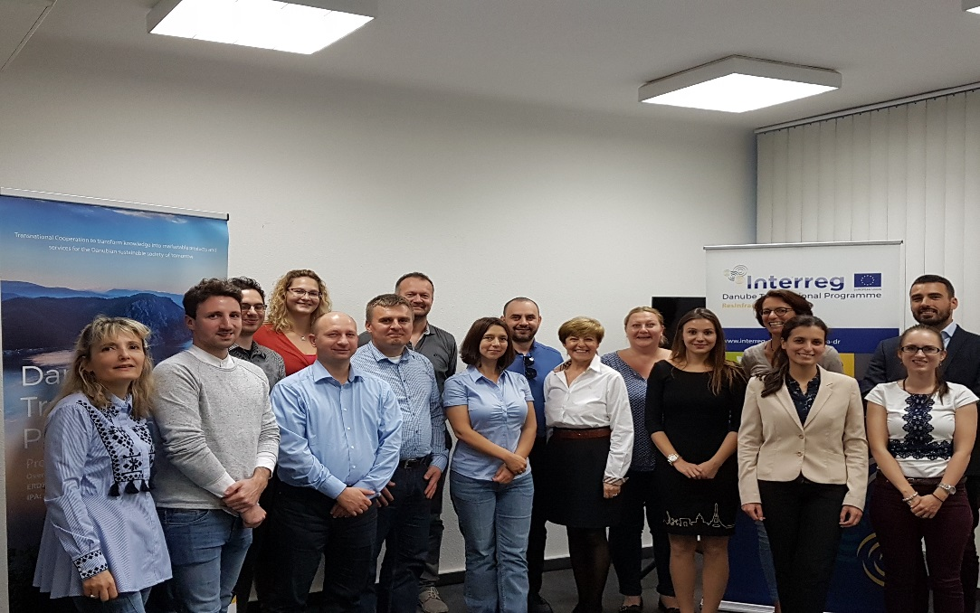

October 17, 2017 Budapest

