Danube S3 Cluster
Transnational Cluster Cooperation active on Agro-Food, based on Smart Specialization Approach in the Danube region

Output
Regional context and cluster innovation potential

Due date of deliverable: 30.04.2020 | Actual submission date: 17.03.2020

Document Control Sheet
Work package number | WP3
Work package title | Joint S3 Cluster Strategy
Activity number | A 3.1
Activity title | Transnational analysis of Danube regional context and cluster innovation potential
Output number | O 3.1
Output title | Regional context and cluster innovation potential
Dissemination level | Public
Main author | Dr. Clémentine Roth (S2i)
Contributors | Dr. Katrin Hochberg (S2i), all partners
Quality Assurance | Evelyn Bako (PBN)

Versioning and Contribution History
Version | Date | Author/Editor /Reviewer | Description/Comments
_v01 | 29.11.2019 | Dr. Clémentine Roth (S2i) | First draft
_v02 | 15.01.2020 | Dr. Clémentine Roth (S2i) | Second draft
_v03 | 19.02.2020 | Dr. Clémentine Roth (S2i),  Dr. Katrin Hochberg (S2i) | Third draft including comments from Workshop in Sárvár
_v04 | 03.03.2020 | Dr. Katrin Hochberg (S2i) | Fourth draft including information from SMRDA, INMA, BEC, NERDA, ITC
_final | 17.03.2020 | Dr. Clémentine Roth (S2i) | Final draft including information from FTS, MTTN, EKO-SUSTAV, IPA, IFKA, BSCSME

Document last saved on | 17.03.2020

Target group assessment
Has this deliverable addressed any of the target group indicated in the application form?
Yes / No
If yes, please describe the involvement of each individual target group in the table below.
Target group | Number reached by the deliverable | Description of target group involvement
SME
Business support organization, Cluster, NGO |  | Cluster managers and members interviewed in the Innovation Audits and contacts made for the preparation of the regional analyses
Higher education and research
Regional and national authority
Civil society, general public

Table of Content
List of Tables 4
List of Abbreviations 5
1 Executive Summary 6
2 Introduction 7
3 Analysis of regional context and cluster innovation potential 8
3.1 The innovation landscape in the Danube region 8
3.1.1 Smart Specialization 8
3.1.2 Innovation governance 11
3.1.3 Research institutions and human resources in R&D 12
3.1.4 Stakeholder cooperation in R&D 12
3.1.5 R&D expenditures 13
3.2 The agro-food sector in the Danube region 14
3.2.1 Niches & specialization 17
3.2.2 Sustainable agriculture / organic farming 17
3.2.3 Rural population (migration & aging) 17
3.3 Education and R&D 18
3.4 Situation of clusters in the Danube region 19
3.4.1 Agro-food clusters in the Danube region 20
3.4.2 Sustainability of clusters 25
3.4.3 Political and financial support of clusters / cluster policies 26
3.4.4 Labels, accreditation and certification 28
3.4.5 International connections and internationalization strategy 30
4 Recommendations 32
5 Conclusion 34
6 Bibliography 35

List of Tables
Table 1: S3 priorities in partner countries 9
Table 2: R&D expenditures in partner countries 14
Table 3: Share of agro-food sector in the GDP and employment in partner countries 15
Table 4: Agricultural products exported by partner countries 16
Table 5: Tertiary education enrolment in partner countries 19
Table 6: Clusters in the agro-food sector in Danubian countries that are registered on ECCP 21
Table 7: Main focus of agro-food clusters in the Danube region 23
Table 8: Labelled clusters in the Danube region (ESCA) 29

List of Abbreviations
D | Deliverable
ECCP | European Cluster Collaboration Platform
EEN | European Enterprise Network
ECEI | European Cluster Excellence Initiative
ECEF | European Cluster Excellence Foundation
EIS | European Innovation Scoreboard
ESCA | European Secretariat for Cluster Analysis
GDP | Growth Domestic Product
GII | Global Innovation Index
HER | Higher Education and Research institution
ICT | Information and Communication Technology
IPR | Intellectual Property Right
IT | Information Technology
KET | Key Enabling Technologies
MCP | Moldova Competitiveness Project
O | Output
OPIC | Operation Programme Innovation & Competitiveness
OPRI | Operation Programme Research & Innovation
PA | Priority Area
RCDP | Rural competitiveness development program
R&D | Research & Development
RDI | Research Development and Innovation
RDP | Rural Development Programme
RRDP | Rural Region Development Programme
S3 | Smart Specialization Strategy
SIEA | Slovak Innovation and Energy Agency
SME | Small- and Medium-sized Enterprise
USAID | United States Agency for International Development

Executive Summary
This document synthesizes the findings of 11 regional analyses on cluster innovation potential (D3.1.2) prepared by Danube S3 Cluster project partners and of the innovation audits report (D4.2.1). It takes stock of different activities carried out in the first half of the project and represents the first project milestone. This synthesis or transnational analysis corresponds to a project output (Output 3.1). This output will be presented and discussed with partners and stakeholders during the first policy dialogue workshop and transnational workshop in Sárvár (Hungary) on 21-22 January 2020.
The objective of the transnational analysis is twofold:
- Identify strengths, weaknesses, opportunities and potential of agro-food clusters in the Danube region
- Lay the ground for a transnational cluster strategy (to be ready in April 2020)
The analysis (Section 3) shows that governments in the Danube region have deployed efforts in the last years to support innovation in enterprises, research institutions and clusters. Nevertheless, there remains a clear gap between countries as regards public support for innovation (both financial and non-financial), private and public R&D investment, cooperation (e.g. between research institutions and companies), knowledge transfer, but also processes and capacity (e.g. strategy, patenting).
The importance of the agro-food sector in the Growth Domestic Product (GDP) and employment varies across the partner regions. However, all countries but Baden-Württemberg have set agro-food related priorities in their smart specialization strategies. There are a few areas in which partner countries are strong and could further specialize such as wood processing sector, organic food, functional food and food processing for instance.
The regional reports show a frequent mismatch between the knowledge conveyed through the education system and the skills demanded by the labour market. In addition, there is also some mismatch between basic and applied research as well as a need for more (public) efforts towards innovation and technology transfer. Agro-food clusters in the Danube region show a great variation in terms of their maturity, activities, degree of internationalization, public support and sustainability.
The recommendations provided in Section 4 are structured along five intervention areas (mapping and visibility; internationalization and cooperation; cluster policy and supporting schemes; monitoring benchmarking and accreditation; and cluster management support programmes). For each intervention area, 3-5 recommendations are made. These recommendations will be discussed and revised during two policy learning dialogue workshops in Sárvár and Bratislava.
Based on this transnational analysis, the Danube S3 Cluster consortium will develop its vision, mission and priorities that will structure the regional strategy.
This document is an Output (O3.1) that relates to the first specific objective of the project: “Develop smart and coordinated cluster policies and related implementing instruments in the Danube region, using smart specialization approach”. Indeed, this output makes preliminary recommendations and serves as basis for the elaboration of a joint strategy containing policy recommendations. This output addresses different target groups: clusters (both members and managers), policy makers but also SMEs and Higher Education and Research institutions (HER).

Introduction
This analysis provides a synthesis of 11 regional analyses of context and cluster innovation potential (D3.1.2) prepared for each of the partner regions (Baden-Württemberg, Bosnia-Herzegovina, Bulgaria, Croatia, Hungary, Moldova, Romania, Serbia, Slovakia, Slovenia, Ukraine) by project partners. It also includes findings from the report on the 205 innovation audits carried out by partners with cluster managers and clusters members in the agro-food sector (D4.2.1) in the course of 2019.
The objective of this comparative analysis is to identify similarities, specificities and complementarities between of agro-food clusters in the Danube region. In addition, it aims at developing preliminary recommendations for policy interventions. The analysis is structured around two main sections (Analysis and Recommendations). The analysis section focuses on:
- The innovation landscape in the Danube region
- The agro-food sector in the Danube region
- Education and R&D
- The situation of clusters in the Danube region
The recommendations section is divided into five intervention areas:
- mapping and visibility
- internationalization and cooperation
- cluster policy and supporting schemes
- monitoring benchmarking and accreditation and
- cluster management support programmes.
This document, which corresponds to a project output (O3.1), is “the first stage for the development of the S3 Cluster Strategy” (Application Form p.64). The Danube S3 Cluster Strategy will constitute another output (O3.3). The main findings of this analysis will be presented and discussed during the first policy learning dialogue in Sárvár on 20-21 January 2020. This documents directly contributes to the achievement of the first specific objective of the Danube S3 Cluster project: “Develop smart and coordinated cluster policies and related implementing instruments in the Danube region, using smart specialization approach”.

Analysis of regional context and cluster innovation potential

The innovation landscape in the Danube region

3.1.1 Smart Specialization
Through Smart Specialization Strategies (S3), countries or regions can identify the most promising areas for innovation based on their respective local strengths. Among the 11 partner countries/regions, six opted for a national S3 strategy, while two countries/regions (Baden-Württemberg, Romania) developed a regional S3 strategy. Bosnia-Herzegovina, Moldova and Ukraine do not have a smart specialization strategy yet, however, the latter two are already engaged in an S3 preparation processes.
In developing their smart specialization strategies, five countries/regions have engaged a variety of stakeholders in identifying their priorities for innovation, thus ensuring an inclusive and dialogue-oriented approach. Three countries/regions, namely Hungary, Moldova and Ukraine have either already initiated or are currently in the process of initiating a dialogue with stakeholders on key innovation areas as a first step towards drafting their smart specialization strategy.
In the comparison of S3 priorities, most of the countries/regions have decided on an agro-food related priority, often relating this area to health, environment, bioeconomy, or sustainability. The only region without an agro-food priority is Baden-Württemberg which has a strong focus on new technologies, mobility and renewable energy. Other cross-cutting priorities are mobility/vehicles (Baden-Württemberg, Croatia, Hungary, Romania, Slovakia) and Health/Medicine/Pharmaceuticals (Baden-Württemberg, Moldova, Romania, Slovakia, Slovenia).
The characteristics of the 11 countries/regions in their approach to smart specialization are summarized in the table below (Table 1). Topics relating to agro-food are marked in bold.

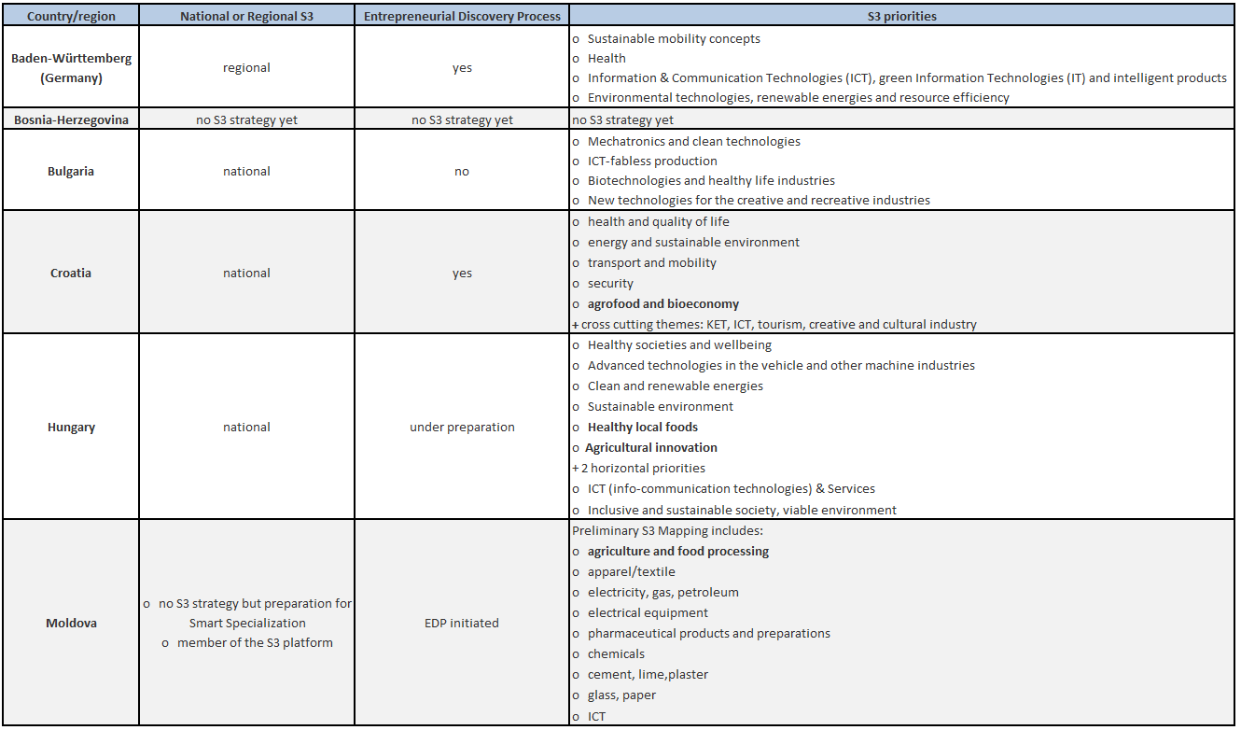
Table 1: S3 priorities in partner countries

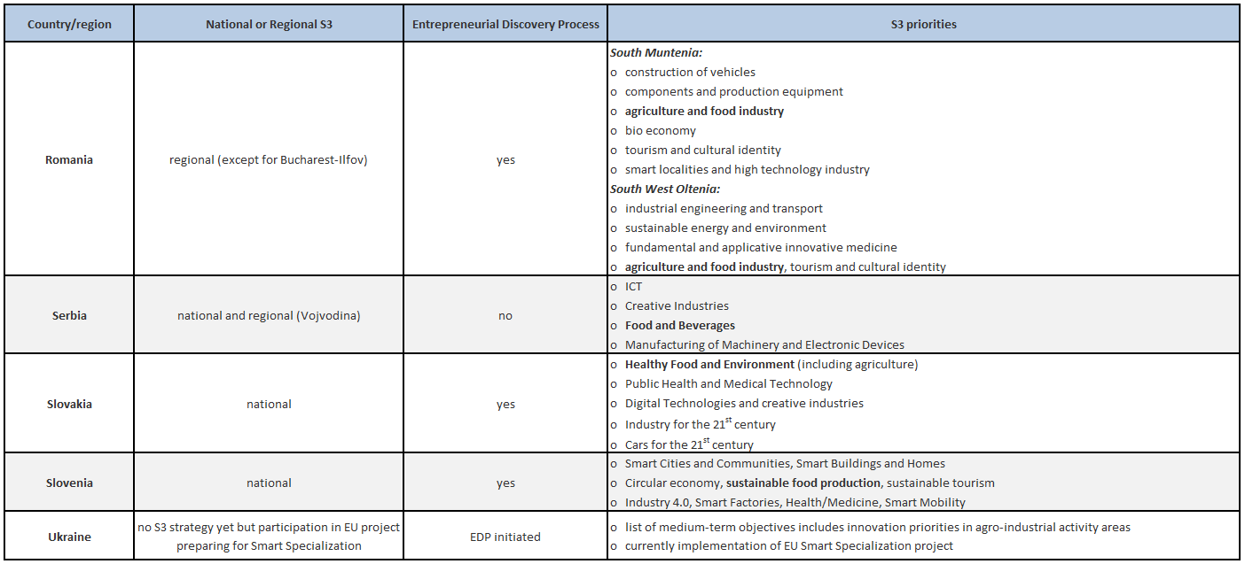

3.1.2 Innovation governance
Given the differences in economic strength between the countries/regions analysed, it is not surprising that their innovation governance shows an equal range from very weak to remarkably strong political support of research, development and innovation. According to the Global Innovation Index (GII) (2019), five of the countries are part of the high-income group (Germany, Slovenia, Slovakia, Hungary, Croatia), four countries are in the upper middle-income group (Bulgaria, Bosnia-Herzegovina, Romania, Serbia) and two countries are in the lower middle-income group (Moldova, Ukraine). Among the high-income group, Germany stands out as one of the top ten innovators, placing 9th in the total innovation ranking. Slovakia, Slovenia, Hungary and Croatia are classified as “moderate innovators” by the European Innovation Scoreboard (EIS) (2019), taking GII ranks between 36th and 44th position. Bulgaria and Romania are among the top ten innovators in their respective income group in the GII and defined as “modest innovators” by the EIS. Serbia and Bosnia-Herzegovina have a lower innovation score, placing respectively 57th and 79th in the GII. In the lower middle-income group, both Moldova (58th) and Ukraine (47th) are classified as overachievers by the GII.
In most regions, Research and Development (R&D) is an established political priority expressed in various strategic documents, with according public support programs. An exception is Bosnia-Herzegovina where the economy and the state administration are still to a great part in development.
In the majority of countries/regions, the political prioritization of R&D is visible in dedicated support schemes (financial and counselling services), public agencies and other intermediaries fulfilling support functions and acting as link between different stakeholders for business entities and/or scientific research institutions (Baden-Württemberg, Bulgaria, Croatia, Hungary, Romania, Slovakia, Slovenia). However, as pointed out before, the state of Bosnia-Herzegovina is still developing a governmental structure and therefore has neither public funding schemes for small- and medium-sized enterprises (SMEs) nor designated institutions providing support to national R&D players. In the cases of Ukraine and Serbia, there seem to be no institutions providing general financial and/or non-financial support to R&D stakeholders, while individual support mechanisms, namely regional innovation funding (Ukraine), and entrepreneurship support such as innovation vouchers (Serbia), exist. Moldova likewise has no dedicated institution providing innovation support, and despite having both, support mechanisms for SMEs/start-ups, and public R&D funds, there are no dedicated R&D funds for companies. Instead, R&D is driven by public authorities and public funds are directed towards public research institutes.
As for the weaknesses in the respective innovation systems, one major critique across countries/regions is insufficient public R&D funding (Baden-Württemberg, Bulgaria, Hungary, Romania, Serbia, Slovenia, Ukraine). Other weaknesses are related to an insufficiently developed innovation infrastructure (Bosnia-Herzegovina, Croatia, Hungary, Ukraine), shortcomings in building a long-term and regionally adapted R&D strategy (Bulgaria, Hungary, Slovenia, Slovakia, Ukraine), fluctuations in R&D government responsible personnel (Slovakia, Slovenia), a legal environment unfavourable for business innovation (Bosnia-Herzegovina, Croatia, Moldova, Ukraine), and a misguided focus in public R&D support towards scientific rather than marketable results (Hungary, Moldova, Serbia, Slovakia).

3.1.3 Research institutions and human resources in R&D
Apart from the national / regional government policies, innovation is highly dependent on the research institutions and R&D human resources present in a country or region and the research approach – applied or scientific – pursued by these. Seven countries/regions report a broad and diverse research landscape, consisting of public and private, university and non-university research and technology transfer institutions (Baden-Württemberg, Croatia, Hungary, Romania, Serbia, Slovakia, Slovenia). Furthermore, research in Baden-Württemberg, Croatia, Hungary, Serbia and Slovakia has earned international recognition – as a whole or regarding specific research areas – and is well connected to international / EU research activities. However, research is often not backed by a sufficient number of R&D specialists: seven countries/regions indicate a shortage in qualified (scientific) workforce (Baden-Württemberg, Bosnia-Herzegovina, Bulgaria, Hungary, Moldova, Slovakia, Ukraine), a problem often linked to a “brain drain” to countries which offer better job opportunities and living conditions.
Another common challenge in developing and advancing R&D which has been reported by several countries/regions is the translation of (scientific) research into practice (Baden-Württemberg, Hungary, Moldova, Romania, Serbia, Slovenia, Slovakia). Referring to this challenge, countries/regions have pointed to a lack of institutions dedicated to technology transfer and a weak support of applied research and marketable research results.
Furthermore, regional disparities reported by countries/regions in terms of economic strength are mirrored in a likewise asymmetrical geographic distribution of R&D activity: In Bulgaria, Romania, and Slovakia R&D is clearly concentrated in the respective capital area.

3.1.4 Stakeholder cooperation in R&D
The degree to which R&D stakeholders cooperate in a country/region is a crucial factor in ensuring technology transfer and the applicability and hence economic success of innovation which has been mentioned as common challenge in the above section. R&D cooperation does not only refer to academia and business entities, but also to government R&D institutions and, if established, the (public) agencies which have been tasked with delivering innovation support and often acting as intermediaries. Even though the exchange between R&D stakeholders in the various countries/regions varies significantly, all countries/regions consider stakeholder cooperation a weakness in their respective innovation system. This underlines stakeholder dialogue as a major challenge and key factor for innovation, even in comparatively mature innovation systems.
About half of the countries/regions suggest a low degree of cooperation between industry and academia, both in terms of universities and research institutions (Bulgaria, Hungary, Moldova, Romania, Slovakia, Croatia). Only Hungary, Moldova, and Ukraine specifically point at a weak cooperation between the state and the private sector, resulting in a research which is not led by industry demand. As for individual cases, Bosnia-Herzegovina indicates an unwillingness of companies to cooperate with one another in R&D, while Ukraine states the same reluctance to cooperate for science organizations.
With respect to initiatives to foster stakeholder dialogue, four countries/regions refer to existing platforms for interaction (Baden-Württemberg, Croatia, Slovenia, Slovakia). Two countries, Serbia and Ukraine, emphasize a growing stakeholder cooperation in the field of Intellectual Property Rights (IPR) / patenting.

3.1.5 R&D expenditures
A further defining characteristic of innovation systems is the role of the public and private sector in R&D investment. Public R&D expenditures should stimulate companies to (co-)invest in innovation, minimize the risk associated with R&D, and ensure that basic and necessary R&D investment is made. The degree of private R&D investment on the other hand is an indicator of whether companies have already established an innovation culture and regard R&D as an integral part of their business, independent from public R&D investment. The analysis of the 11 countries/regions in terms of R&D expenditures reveals a broad prevalence of private R&D expenditures in 8 countries / regions (Baden-Württemberg, Bulgaria, Croatia, Hungary, Romania, Slovakia, Slovenia, Ukraine), while R&D expenditures in three countries/regions, namely Bosnia-Herzegovina, Moldova and Serbia are predominantly carried by the public sector.
Unsurprisingly, among the 11 countries/regions, Baden-Württemberg has the highest total R&D expenditures with 5.6% of the Gross Domestic Product (GDP), which confirms its status as strong innovator. However, total R&D expenditures in Hungary (1.4% of GDP) and Slovenia (1.9% of GDP) are likewise comparatively high. Regarding the amount of R&D expenditures by the private sector, Baden-Württemberg (80% of total R&D expenditures), Hungary (74% of total R&D expenditures), and Slovenia (74.7% of total R&D expenditures) stand out with remarkably high business commitment. Interestingly, the public and private share in total R&D expenditures in Slovakia and Serbia is comparatively balanced.
Another particular feature is the key role of large, foreign-owned companies in R&D investment which has been reported by Bulgaria, Croatia, and Hungary. On a more general level, Bosnia-Herzegovina, Bulgaria, Croatia, Moldova and Slovenia point out that companies often lack the capability in terms of personnel and/or investment, or the self-image to engage in innovation or even entrepreneurial activities.
The following table (Table 2) depicts the share of R&D expenditures in the GDP as well as the predominant origin of R&D (public or private) in the partner countries.
Table 2: R&D expenditures in partner countries
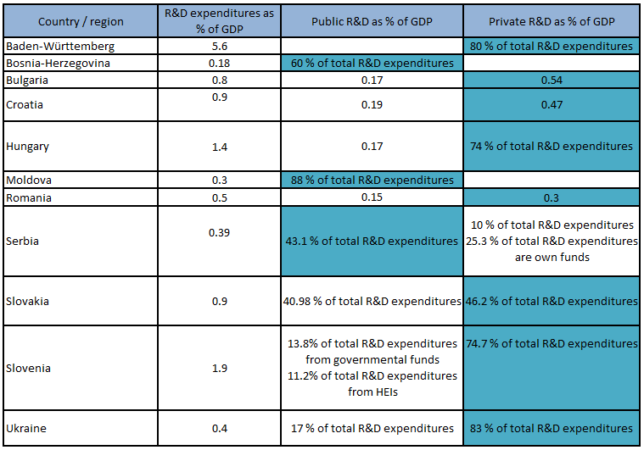
Sources: www.globalinnovationindex.org/home ;
https://ec.europa.eu/eurostat/databrowser/view/tsc00001/default/table?lang=de e
https://insse.ro/cms/en
http://ndch.diit.edu.ua/ua/about/otchet2016.php

Legend: xxx = cell marked in blue shows where the predominance of R&D (private or public) is

The agro-food sector in the Danube region
This section concentrates on the share of the agro-food sector in the GDP and employment in the partner countries. Partner countries can be categorized in 4 groups:
- Most developed countries in the Danube Region with small share of agriculture in the total economic activity: Germany, Slovenia, Slovakia
- Less developed countries where agriculture does not constitute a key economic activity: Hungary, Croatia, Bosnia-Herzegovina, Bulgaria
- Less developed countries, but with relatively greater importance of agriculture in the overall economy: Romania, Serbia, Ukraine
- The least developed country with the dominant role of agriculture in the overall economy: Moldova
Table 3 shows the important variations regarding the importance of the agricultural sector in the foreign trade in the Danube Region countries.
Table 3: Share of agro-food sector in the GDP and employment in partner countries
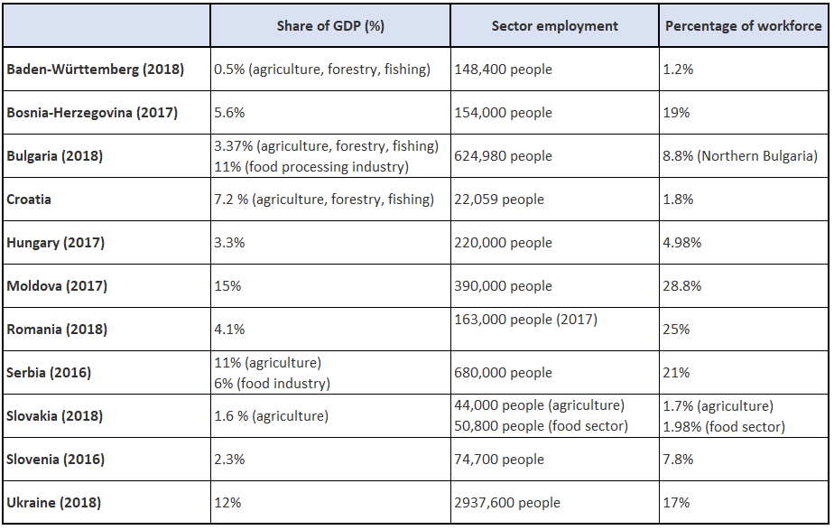
As already mentioned, agriculture/food industry/bioeconomy – and more generally what pertains to agro-food – is a smart specialization priority in most partner countries. Bulgaria, Hungary, Serbia, Moldova and Ukraine have a very high positive foreign trade balance in the agricultural sector. In Ukraine for instance, agricultural exports are an important part of the economy as it generates around 40% of the national foreign currencies revenues. Although the share of agriculture in the GDP of Baden-Württemberg is very small, the region has strong trading relations with Višegrad countries (Czech Republic, Slovakia, Poland and Hungary) and has cooperation agreements with Bulgaria (viniculture), Hungary (viniculture and wine tourism, seeds) and Serbia (cultivation of generically unmodified soy, agro-food value chain).
Table 4 below provides an overview of the main products that are exported by each of the partner regions. This table is based on the information provided in the regional reports.
Table 4: Agricultural products exported by partner countries
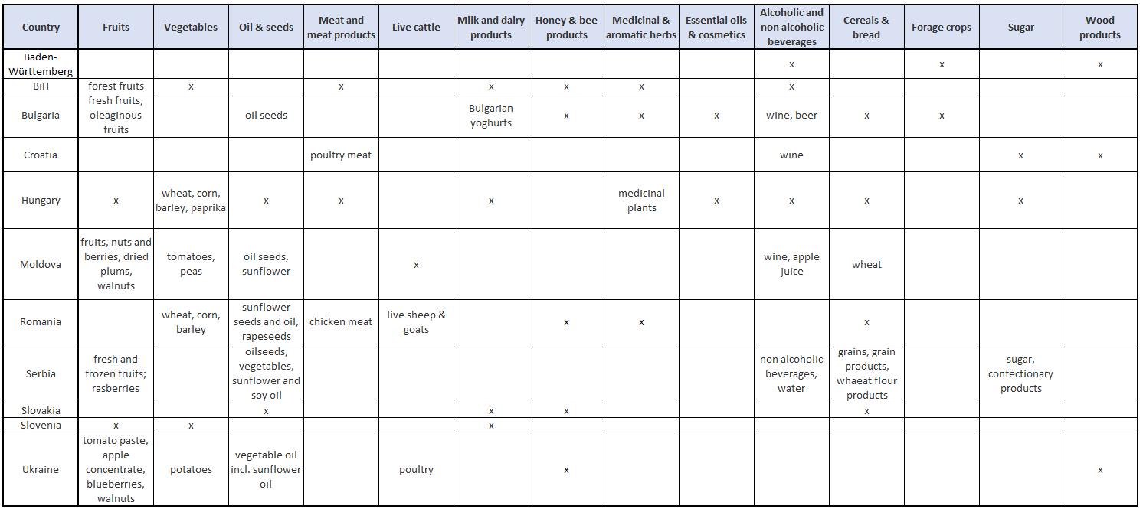

3.2.1 Niches & specialization
The analysis of the regional reports allows to identify niches or at least sectors in which several partner regions are specialized and have clusters:
- Wood processing sector (in Bosnia-Herzegovina, Bulgaria, Croatia, Romania, Hungary, Slovenia)
- Bioeconomy (Romania, Slovakia, Serbia)
- Food processing (Croatia, Baden-Württemberg, Romania, Hungary, Slovenia)
- Crop and animal production (Romania, Serbia, Bulgaria, Bosnia-Herzegovina, Slovenia, Ukraine)
- Food additives, functional food and biopharmaceuticals (Hungary, Bulgaria, Romania Slovakia, Ukraine)
- Organic food (Serbia, Hungary, Romania, Ukraine, Slovenia)

3.2.2 Sustainable agriculture / organic farming
In line with the current global trend, the Danube partner regions show a growing interest for organic farming and sustainable agriculture. This is noticeable though the number of clusters and cooperatives dealing with organic food (7) or local products/circular economy /sustainable lifestyle (12). See Table 7 for a detailed overview. To give two examples: in Baden-Württemberg organic agriculture is supported by an action plan initiated in 2012 “Bio from Baden-Württemberg” and in Romania, organic agriculture is supported through Rural Development National Programme 2014-2020 while innovative technologies dedicated to organic agriculture are supported by RDI National Plan 2015-2020.
The goal of sustainable agriculture is to meet society’s current food and textile needs without compromising the ability of future generations to meet their own needs. Organic farming is an agricultural system that uses ecologically based pest controls and biological fertilizers derived largely from animal and plant wastes and nitrogen-fixing cover crops. It ensures healthy farming and healthy food for today and tomorrow, by protecting soil, water and climate, promotes biodiversity, and does not contaminate the environment with chemical inputs or genetic engineering. Organic farming can become a professional field notably through cooperation in vocational training. Besides, cross-border university cooperation in agricultural studies could increase academic research interest in agri-science and build expertise.
Danube S3 Cluster will set its emphasis on promoting organic farming and bioeconomy and will aim at increasing links between food, farming and health on the one hand side and at strengthening sustainable practices and circular economy on the other. Healthy food and circular economy will for instance be the focus of at least three local action plans.

3.2.3 Rural population (migration & aging)
With the notable exception of Baden-Württemberg, all other partner reports mention brain drain and rural depopulation as major issues. Rural areas are particularly concerned with a double phenomenon of migration: rural-urban migration (within the country) and international migration (outside the country).
The share of the agricultural sector in the GDP tends to decrease due to different factors:
- Arable land being replaced by construction and transport infrastructure (Slovenia, Ukraine)
- Decline in domestic food production (Slovakia)
- Migration
- Difficulty to find young farmers / entrepreneurs (linked to aging population)
- Diversification of activities in rural areas
In some regions (Romania, Moldova, Croatia), agricultural activities represent the major source of employment in rural areas so that the decreasing share of agriculture feeds the exodus. On the other hand, the phenomenon of aging population is particularly strongly felt in the agricultural sector with acute difficulty to find young farmers / entrepreneurs to take over farms – which are often family farms (Slovenia).
In Romania and Moldova, a lack of associative culture is pointed out. Interestingly, while this clearly hinders the development of clusters in Moldova, it is not the case in Romania.
In the Danube region, it is possible to distinguish between regions in which the agricultural sector is characterized by a small number of big farms/agricultural holdings (Hungary, Romania, Moldova, Serbia) and a majority of micro and small (family) farms (Slovenia, Baden-Württemberg, Croatia).
Major findings:
- Different factors (migration, aging, non-agricultural sector) add up and contribute to a shortage of labour
- Brain drain is an acute problem

Education and R&D
The importance of education on a country’s or region’s innovation potential is uncontested. Education is critical in enhancing the chances for employment and in creating the knowledge needed to contribute to or raise the national/regional economic performance. In this respect, the amount of financial resources dedicated to education may have a significant impact on a country’s/region’s economic development.
According to the GII (2019), the countries/regions analysed range between 6.7% (Moldova) and 3.1% (Romania) of the national GDP in their expenditures on education (see Table 5). Furthermore, tertiary education enrolment is lowest in Moldova (41.1%) and highest in Ukraine (83.4%) and Slovenia (77.6%). However, many countries/regions report a decrease in the number of students over the past years, a phenomenon partially connected to the “brain drain” of young people to countries with better job and academic opportunities (Hungary, Moldova, Ukraine, Romania, Serbia, Slovakia). As pointed out in the above section, the migration of young and qualified people to other countries has a negative effect on the innovation potential, as it results in a lack of qualified workforce.
Several country/regional reports have also pointed out a mismatch between the knowledge conveyed through the education system and the skills demanded by the labour market (Bosnia-Herzegovina, Bulgaria, Croatia, Moldova, Slovakia, Slovenia). Translated into the research context, this critique has also been raised in the form of a gap between applied and basic research and the need for more (public) efforts towards technology transfer.
In order to boost innovation, applied research – namely in the fields of science and engineering – is an important focus which needs to be backed by a sufficient number of graduates. Among the 11 countries/regions, Baden-Württemberg stands out with 41% of graduates in science and engineering, a position which confirms this region’s innovation priorities and regional strengths. With almost 30% of graduates in these fields, Romania has the 2nd highest result. Yet, apart from Baden-Württemberg, the overall range of this indicator is only around 20% to 30%, which suggests that the situation is quite comparable across these countries.
Table 5 depicts the percentage of tertiary education enrolment as well as the percentage of expenditures on education as compared to the overall GDP.
Table 5: Tertiary education enrolment in partner countries
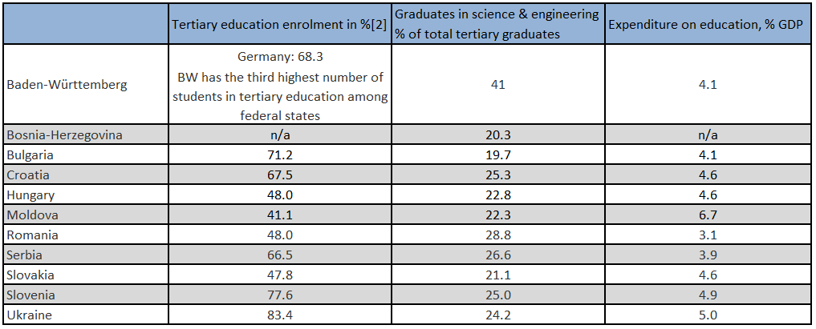
Sources: GII (2019),
State Statistical Office Baden-Württemberg (2018): Baden-Württemberg – ein Standort im Vergleich retrieved from www.statistik-bw.de/Service/Veroeff/Querschnittsver!F6ffentlichungen/803618001.pdf

Situation of clusters in the Danube region
The situation of clusters in the Danube region is marked by great diversity in terms of their maturity, their focus/profile as well as their activities.
It is possible to distinguish between three main categories of regions: regions with mature clusters, regions with first generation of clusters and finally regions that are for different reasons “in-between”. These three categories are not to be taken rigidly but rather aim at facilitating comparison and allowing to develop recommendations at a transnational level.
Romania, Hungary and Germany belong to the first category. These countries have mature clusters including in the agro-food sector. A precision needs to be made regarding the German case: there are mature agro-food clusters but the only agro-food cluster in Baden-Württemberg has been set up in 2018. However, the decision to classify Germany in this category is based on the fact that there is well established cluster policy both at the national and regional level since more than 10 years. The maturity does not only correspond to the “age” of the clusters but also reflect the capacities, activities and level of development and internationalization of the clusters.
Moldova, Ukraine, Bosnia-Herzegovina, Croatia and Bulgaria can be classified in the second category: regions with first generation of clusters. In these countries, there are clusters – also in the agro-food sector – however the lack of consistent or systemic cluster policy and various barriers slacken the development of clusters. In Moldova, the most advanced form of cooperation in the agricultural sector consist in groups of producers (stipulated by the law n°132 from 20.12.2013 on agricultural producer groups and their associations). Currently 32 groups of producers have been recognized with this status. Farmers are reluctant to form associations, which is due to the large distances between farms of similar types. In Bosnia-Herzegovina, the Agency for Development of SMEs supported in 2007 the creation of several clusters from its funds (Drvo-G association, Cluster doboj, cluster Drina Drvo Srebrenica, Cluster Solar group). The first three are related to wood processing / agro-food. In addition, an integral part of the Rural competitiveness development program (RCDP) from 2015 consists in the establishment of five agro-food clusters: K1 (berry fruit); K2 (berry fruit, medicinal and aromatic herbs, forest fruit); K3 (vegetables”; K4 (vegetables); K5 (vegetables). However, these clusters remain at an early stage of maturity. There are in total 6 informal agro-food clusters registered as citizen’ associations.
Finally, Serbia, Slovakia and Slovenia can be said to be an in-between situation. In Slovakia, clusters are established as associations of legal entities, which act as non-profit organizations. Cluster members can only be legal entities. Recently, the number of cluster initiatives has significantly increased in Slovakia: In 2018, there were 56 registered clusters though only some 20 are active including 2 in the agro-food sector. Although Slovakia has several mature clusters there are only two relatively young agro-food clusters. As for Slovenia, there are mature clusters especially in the ITC sector. There are 3 agro-food clusters, but farmers and food processing companies have the tendency to cluster in other ways such as cooperatives or under the umbrella of different institutes and associations. As for Serbia, the establishment of the first clusters in the agro-food are dating back to the early 2000 and there are quantitatively quite a large number of clusters: 31 clusters related to agro-food, five clusters-clustering institutions and five associations relevant for agro-food sectors. However, only few of these clusters are really active and mature in terms of development (triple or quadruple helix) and internationalization.

3.4.1 Agro-food clusters in the Danube region
It seems relevant to discuss “what makes a cluster”. There are two main dimensions: status and activity. Regarding the status, we can distinguish between nominal clusters as opposed to active clusters. Hence, the legal status as cluster does not always reflect the real activities of the structure. The discrepancy between the number of nominal and that of active clusters varies across countries with a higher proportion in countries such as Serbia, Bosnia-Herzegovina but also Slovakia.
Concerning the activity, here it is pertinent to distinguish between nominal clusters that are not active and other structures that act as clusters though informally as it is the case in Slovenia, Bulgaria, Serbia and Croatia. The form of these informal clusters is varied and ranges from associations, cooperatives, groups or community of producers.
In order to get an overview of the existing clusters in the agro-food sector, the following table (Table 6) lists the clusters in partner countries that are registered on the European Cluster Collaboration Platform (ECCP). This list corresponds to the situation in January 2020.
Table 6: Clusters in the agro-food sector in Danubian countries that are registered on ECCP
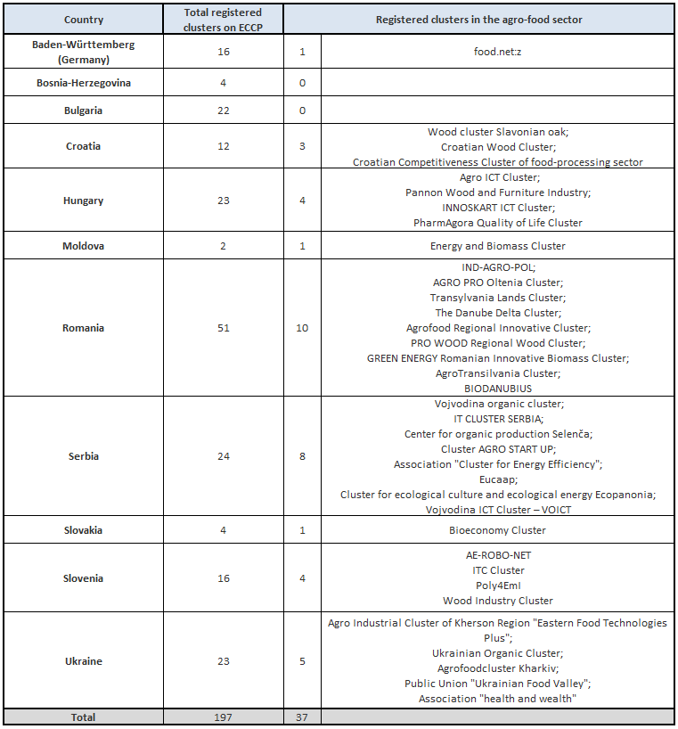

This overview will help partners identify existing clusters in the agro-food sector in their country/region that are not yet registered on ECCP. One project activity consists in bringing at least 10 clusters to register on the platform.
What the regional reports and this table shows is that there are no official and/or registered clusters in the agro-food sector in a few partner regions (Bosnia-Herzegovina, Bulgaria, Slovenia). In terms of thematic focus, it is possible to classify them in nine main categories:
- bioeconomy,
- wood processing,
- digitalization in agriculture,
- food processing, advanced packaging, crop & animal production,
- Biofuels & energy efficiency,
- Food additives / functional food / biopharmaceuticals,
- organic food,
- Sustainable lifestyle / local products / tourism / circular economy,
- agriculture machinery
Table 7 provides a detailed list of the existing clusters according to these thematic foci. This includes the registered clusters on ECCP as well as non-registered clusters.

Table 7: Main focus of agro-food clusters in the Danube region
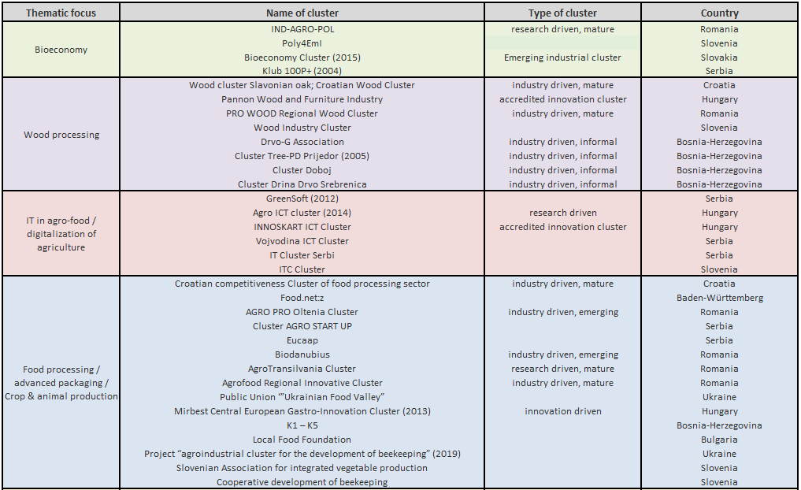
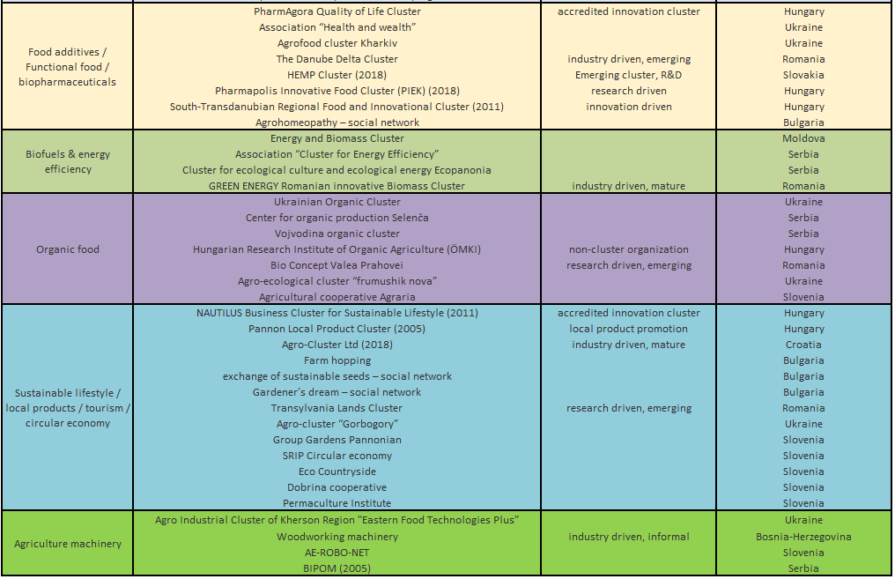
To summarize the main findings:
- Not all partner regions have official clusters in the agro-food sector
- There are in several countries a discrepancy between the number of registered clusters and that of active clusters
- As regards the activity of clusters, it is not enough to focus on formal active clusters, but one should also include “informal” clusters
- Many clusters in the agro-food sector are not yet registered on the ECCP platform
- There is a clear divergence in terms of the maturity of clusters across the partner regions

3.4.2 Sustainability of clusters
A major issue concerns the sustainability of clusters, in other words how can clusters finance their activities. Clusters have different possibilities such as public funds, external funds (e.g. through participation in international projects), membership fee, sources from provision of services to cluster members. The regional analyses show again a diversity of situation across the Danube region.
Membership fee: Membership subscription represents a good resource for clusters. However, while in some regions this represents the main source of funding (for instance 70% of the cluster Food.net:z in Germany), in a country like Hungary, there is a low willingness of cluster members to pay membership fees. In such cases, it would be recommendable for clusters to discuss what would be a “fair” fee acceptable for members.
Public funding: Public support for clusters is not available in all countries or is very limited (e.g. Bulgaria, Slovakia). Besides, public support may vary from year to year so that cluster management cannot rely on this funding source. In Bosnia-Herzegovina on the other hand the registration as clusters is linked to funding so that some sector associations formally register as cluster in order to receive funding although they do not act as clusters.
External funds: External funds can include funding from other countries or funds for participating in international projects. In Serbia various clusters were setup and financed by other countries and/or the EU in the frame of projects. However, in most cases these clusters proved to have been artificial creations with short lifespan that collapse when this funding ends. The participation in projects is however a good way for clusters to finance themselves. Slovak clusters show a high involvement in such transnational projects. The recently published White Paper on the Capacities of Strengthening Cluster shows that in the Danube countries, due to the fact that there is less political support for clusters, clusters are more able to attract private funds and are therefore less dependent on public funding.
Own resources: through provision of services or bank loans for instance. Slovak clusters face problems when getting bank loans or leases.
To summarize the main findings:
- The situation is currently characterized by a lack of systemic (public) support
- A system of multi-source financing (funding mix) is recommendable

3.4.3 Political and financial support of clusters / cluster policies
The regional reports show a diverse picture of political and financial support of clusters. When there is state support, the responsibility and competence for cluster policy mainly depend on the national or regional ministry of economy: Ministry of National Economy (Hungary), Ministry of Economic Affairs, Labour and Housing (Baden-Württemberg), Ministry of the Economy, Entrepreneurship and Crafts (Croatia), Ministry of Economy (Slovakia), Ministry of Economy (Moldova).
In Slovakia, clusters are not yet backed by a dedicated cluster policy nor a specific support program. However, the Ministry of Economy has launched in 2013 a scheme to support industrial cluster organizations. This scheme only supports projects of non-investment character. Between 2013 and 2018, five calls were launched with a total allocation of 815 000 EUR for clusters.
In Serbia, there is public support for clusters and clustering. However, this political support remains mainly declaratory and is not backed by (real) financial support. While governmental institutions used to financially support the participation of clusters to international fairs, this support is limited to very few cases.
In Baden-Württemberg, there is strong public support. The ministry of economic affairs, labour and housing supports the development and further advancement of clusters and networks. The cluster policy is characterized by a dialogue-oriented approach: Policy instruments are developed in dialogue with regional cluster actors, cluster initiatives and state-wide networks. Public support includes financial support for innovative projects of clusters, support for internationalization, organization of national and regional cluster events, publications and studies on relevant topics for clusters, quality labels for cluster management.
In Hungary, state support for clusters dates back to the beginning of 2000 with the launch of the Széchenyi Plan and then of the National Development Plan (2010). Within a few years, this support led to the formal establishment of 50 clusters. The government opened tenders with the objective of financing management activities. However, the abundance of cluster-related calls led to the creation of clusters focusing on the same industry in a very close proximity. In 2007 started the Pole Programme, which is the first framework of cluster policy and strategy in Hungary and which defined a four-staged development programme for governmental cluster support. The pole programme raised the resources for cluster development and cluster members and also introduced an accreditation process for selecting and qualifying clusters. In parallel to the centrally managed Pole programme, cluster support structure appeared in the operational programs of each region. Within the Ministry of Finance, the International and Cluster Department is the managing authority for economic development programs that is supporting Hungarian clusters. The current cluster policy focuses on professional cluster management (capacity building of cluster management organizations), strengthening international role of clusters, facilitating international market access, encouraging collaboration between clusters, shifting the support for start-up clusters towards the further development of existing clusters.
The Moldova Competitiveness Project (MCP) (2015-2020) is funded by the United States Agency for International Development (USAID) and Sweden. This project supports Moldova’s efforts to promote a strong, diverse and export-oriented economy by improving competitiveness and efficiency in key industries. MCP focuses on three areas: ICT clustered with creative services and precision engineering; wine production and export clustered with the tourism sector; and light industry (clustered textiles and apparel with footwear sectors). MCP supports clusters or “ready to grow” industries including wine and tourism. The Moldovan Ministry of Economy is the initiator and coordinator of cluster policy implementation at the national level. It 2013, it launched the concept of industrial cluster development and in 2018 published a methodological guide “creating and organizing clusters in the Republic of Moldova”. However, although the concept of cluster is present in some strategic policy documents, their creation and development are not yet regulated at the legislative level and there are no concrete supporting mechanisms. This explains why there are no real clusters and no functional clusters in the agro-food sector in the country. On the operational level, the organization for small and medium enterprise sector development (ODIMM) supports cluster development.
In Romania, cluster policy is a component of industrial policy. All Romanian clusters are registered at the Ministry of Economy, Energy and Business Environment which is in charge of cluster policy. National public support of clusters has been in place since the programming period 2007-2013. The new document on industrial policy lists “Smart and sustainable growth through innovation in industry” and “Innovative cluster – tool of a smart industrial policy” as policy priorities. Within the areas of activity identified in the document, the development of an integrated and coherent policy for the support of innovative clusters indicates dedicated public support of clusters. In the present programming period, funding for innovative clusters including those from the agri-food sector is based on national and European funds.
In Croatia, the Cluster Competitiveness Program is sponsored by the Ministry of the Economy, Entrepreneurship and Crafts. The Croatian cluster policy distinguishes between business clusters (under responsibility of ministry of entrepreneurship and crafts) and competitiveness clusters (under responsibility of ministry of economy). Business clusters are mainly SMEs networking to foster international cooperation, raw material supply or promotion whereas competitiveness clusters provide a formal structure of cooperation based on the triple helix model (companies, public authorities and HER). At the regional level, cluster policy is also promoted in the frame of regional economic development policies.
In Bulgaria, the operational programme “innovations and competitiveness” (OPIC) for the period 2014-2020 has announced schemes for funding cluster initiatives. However, the agro-food sector is not targeted to avoid double funding with the Rural Region Development Programme (RRDP). The RRDP has funded 38 projects at the end of 2018 under Measure 9 “establishment of groups and organizations of producers”. Even though the measure aims at supporting initial clustering activities in the sector, it is greatly fragmented, and its representative sector associations do not have typical cluster features. Similarly to the situation in Bosnia-Herzegovina, funding is based on the legal status as cluster and on formal criteria, which associations can fulfil without proving real on-field clustering collaboration.
In Bosnia-Herzegovina there is no cluster policy and the development of clusters is largely hindered by shortcomings in laws and regulations.
In Ukraine, there is a nascent cluster policy with the idea that national innovation clusters should support the realization of strategic priorities regarding innovation activities.
In Slovenia, clusters are established and operated under the Ministry of Economic Development and Technology. There is no dedicated cluster program in place yet, however, in 2018 the Ministry has launched a program to establish Strategic Research Innovation Partnerships which fulfil cluster-like networking functions and cover different S3 thematic priorities. Formalized clusters often have private funding provided by their members or are using public funds in form of cooperation and research programs (Interreg or H2020).
To summarize the main findings:
- When state support, it is mainly under the competence of the ministry of economy
- State support is not always consistent
- External financial support in Moldova substitutes the lack of political support
- The aim of cluster policies should be to create propitious conditions that encourage, enhance strategic competitiveness in internationally competitive sectors by consciously supporting clustering.
- Political backing needs to be substantiated with financial support

3.4.4 Labels, accreditation and certification
The European Secretariat for Cluster Analysis (ESCA) provides benchmarking and quality labelling of cluster management organizations. ESCA awards three different quality labels to qualified cluster management organizations: bronze, silver and gold labels. To obtain such a label, a cluster management organization needs to fulfil two conditions: the applying organization needs to be benchmarked by an ESCA expert and to fulfil the eligibility criteria for cluster management excellence label.
ESCA cluster benchmarking is based on a personal interview of the cluster manager with an ESCA expert. During the interview, 36 indicators are analysed concerning the structure of the cluster, cluster management and governance, strategy, financing, contacts and interaction with relevant players but also achievements and recognition of the cluster organization.
The process of application, assessment and award differs for each label. A label is awarded for a duration of 2 years. Up to one year after a valid label expires, it can be renewed by repeating the same process. The validity of the label is then seamlessly extended by three years from the previous validity period.
The following table summarizes the current situation of labelled clusters notably in the Danube region for clusters in the categories biotechnology and food industry that correspond to the agro-food sector.
Table 8: Labelled clusters in the Danube region (ESCA)
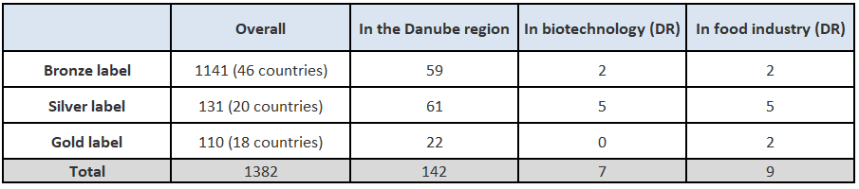
In a few regions/countries there are also national quality labels namely “Cluster-Excellence Baden-Württemberg” (Germany) and “accredited innovation cluster” in Hungary that are linked to ESCA labels.
In Baden-Württemberg, the evaluation process for obtaining the quality label Cluster Excellence Baden-Württemberg follows a standardized process. This process is implemented by VDI/VDE Innovation + Technik who has been assigned by the Ministry of Economic Affairs, Labour and Housing. The quality label is awarded by the Ministry of Economic Affairs, Labour and Housing.
Here are the different steps:
- Submission of evaluation request (possible for any regional cluster initiative or network registered in Baden-Württemberg and listed in the Cluster Atlas/Cluster Database)
- Examination of the evaluation request. If all criteria are fulfilled, then:
- Access to free self-testing tool and completion of the self-test
- Recommendation for evaluation (by VDI/VDE Innovation+Technik GmbH to the Ministry of Economic Affairs, Labour and Housing) and decision of the Ministry.
- If approval ⟶ conclusion of contract between VDI/VDE Innovation+Technik GmbH and the cluster /network (costs charged)
- After completion of evaluation process, recommendation for issuing the quality label "Cluster Excellence Baden-Wuerttemberg" & final assessment
- Award and validity of the quality label
As for ESCA labels, the quality label “Cluster Excellence Baden-Württemberg” is valid for two years. With the award of this label, the applicant automatically receives the EU-Gold-Label without additional costs or reviews.
Since 2010, Hungary through its Pole programme has set up a national system of accreditation. The accreditation process was introduced in order to improve the quality of cluster management and to answer the growing demand for transparency due to the large-scale cluster initiative generated by the open tender system and the difficulties of the pole program. If a cluster is accredited, it acquires eligibility for special technology development call for proposals in the Economy Development Operative Programme dedicated to accredited clusters or to their members. In some special cases, an accredited cluster member can get bonus points during the evaluation process, thus improving approval consideration. As for ESCA labels, the title “accredited innovation cluster” expires automatically after 2 years, and the clusters has to apply for it again. However, some criticisms are raised regarding the accreditation system: for some clusters, the accreditation cluster title is too restrictive. In addition, some aspects of cluster accreditation are not in line with other international cluster certifications, which makes it difficult for clusters to apply for both.
In Slovakia, the Slovak Innovation and Energy Agency (SIEA) supports the re-certification of clusters within the frame of the project ClusterFY. In 2018 and 2019 a total of 16 ESCA labels of excellence have been obtained by Slovak clusters translating a growing interest of Slovak clusters in international certification. SIEA has built an expert team trained within the ESCA and the European Cluster Excellence Foundation (ECEF).
In Romania, CLUSTERO, the Romanian Cluster Association, prepares an annual analysis on the competitiveness of its members based on an internally developed methodology.
To summarize the main findings:
- ESCA labels are internationally recognized labels and clusters should be encouraged to be benchmarked and obtain quality labels
- Quality labels/ certification / accreditation not only provide a guarantee of quality but also increase the visibility and can even provide advantages (as seen in the case of Hungary)
- The setup of national or regional certification systems can help increase the management quality of clusters. It is recommendable for such systems to be in line with ESCA (as it is the case for Hungary and Baden-Württemberg).
- It can be helpful to have an expert group or one-stop-shop that can provide guidance and support regarding certification (as seen in the case of Slovakia)

3.4.5 International connections and internationalization strategy
The regional reports show a great diversity regarding transnational connections and internationalization strategy. In countries such as Slovakia, Romania and Serbia, clusters strongly cooperate with regional and international partners. In other countries such as Bulgaria clusters mostly develop international links within the frame of (EU) projects.
In Bulgaria, the internationalization of clusters is mostly project related. A lot of clusters, which were established with EU project financial support have implemented projects and cooperated with international partners. However, international cooperation is usually limited to the foreseen activities within the project and very rarely develops further into long-term transnational cooperation links.
Given the informality of clusters in Bosnia-Herzegovina, international connections are virtually non-existent.
Similarly, in Croatia, clusters mainly have international connections through their participation in EU and other international projects. Local clusters usually do not have international links as they have a limited market and product range.
In the case of Slovakia, they particularly cooperate with organizations from the Višegrad countries (Czech Republic, Poland and Hungary) but also with Austria, Italy and Germany. These good international connections are related to the fact that Slovak clusters are very active and involved in numerous projects using various programmes and funding schemes. In addition, the Union of Slovak Clusters is a founding member of the European Clusters Alliance founded in September 2019. This newly established structure is “a bottom-up approach dedicated to creating synergies between the various activities of clusters in various countries and speak with one strong voice for the development of further framework conditions for clusters to support the competitiveness and innovation capacity of their SMEs in Europe”.
As for Slovenia, clusters often collaborate with different international partners, notably from South-Eastern Europe, and are involved in research and cooperation projects, mainly through transnational and European programs (such as Danube Transnational Programme, Central Europe programme and H2020 research programme). Under the umbrella of DIH AGRIFOOD, the ITC cluster is also building a network of European partners in the agro-food sector where common projects are being developed and implemented.
As regards Romania, most clusters are members of macro-regional networks (e.g. ClusterPoliSEE, Adriatic Danubian Clustering, Biomastec Danube Network, Balkan and Black Sea Cluster Network, Plant InterCluster ) and/or national networks (RE-IN), national cluster associations (e.g. CLUSTERO-cluster association) or European Strategic Cluster Partnerships – ESCP-4i (e.g. FoodNet – Food in Eco Network, TRACK – Tracking opportunities to develop and strengthen data collection and big data in agri-chain to increase of SMEs). They position themselves in regional and sectoral consortia as well as European networks. Almost all Romanian clusters include representatives of the European Enterprise Network (EEN) as members. In addition, Romanian clusters are very active in brokerage events, company missions and matchmaking.
In Serbia, the relatively strong internationalization of clusters is based on the fact that various clusters were established through external funds and in the frame of international projects. However, there are almost no good example regarding active clusters with strong international connections.
On the other hand the only agro-food cluster in Baden-Württemberg food.net:z – which is relatively young – is not integrated in global networks and does not have an internationalization strategy. It has no linkage with other clusters although it maintains relations with actors of diverse areas (Chamber of Commerce and Industry, foundations, universities and enterprises).
In Hungary the situation is contrasted: Pharmapolis Innovative Food Cluster (PIEK) has many international relationships and an excellent relationship with other clusters, especially with agro-food clusters from other countries whereas Mirbest and South-Transdanubian Regional Food and Innovational Cluster have no active relationship with any foreign clusters and international networks.
In the case of Moldova, clusters’ internationalization initiatives are based on building international links, partnerships, and twinning projects with clusters from other countries and aimed at strengthening the development of Moldovan clusters in the agri-food area. Clusters are supported in building these international links by ministries, embassies, trade and investment organizations, conferences and other international forums which act as facilitators. Moldovan clusters likewise establish international links by accessing international funds targeted at cluster development and access to international markets.
In Ukraine, most agricultural clusters are focused on the domestic market except for the nut cluster and the reed cluster.
The absence of international connections can have different backgrounds: such as focus on own development when the cluster is in an early phase (e.g. food.net:z), lack of capacity (Mirbest) but also lack of contacts.
To summarize the main findings:
- There are clear regional differences in terms of international cooperation and connections
- Internationalization strategy is not so frequent

Recommendations
Based on the 11 regional analyses, we developed a set of recommendations grouped in 5 intervention areas:
- Mapping and visibility
- Internationalization and cooperation
- Cluster policy and supporting schemes
- Monitoring, benchmarking and accreditation
- Cluster management support programmes
At this stage, the recommendations are preliminary and will be discussed during the policy dialogue workshops in Sárvár and Bratislava. The revised recommendations will be an integral part of the Danube S3 Cluster Strategy.
- Mapping and visibility
The concept of clusters/clustering as well as the activities of the existing clusters can and should be more visible. Here are a few recommendations to allow a better mapping and enhance the visibility of clusters:
- Encourage and support clusters to register on the European Cluster Collaboration Platform (ECCP) ⟶ The consortium will prepare guidelines explaining how to create an ECCP profile and will bring at least 10 clusters to register
- Identify and spread good examples of clusters (awareness raising and dissemination among policy makers, entrepreneurs and civil society)
- Encourage clusters to increase their media presence (print and digital media, social networks, forums)
- Support cluster mapping tools (e.g. ECCP, DIH AGRIFOOD, Cluster Atlas) as mean to raise the visibility of clusters
  - The use of mapping tools can help improving policies and programs impacting cluster activities
  - Support the setup of national cluster mapping (e.g. Cluster Atlas in Baden-Württemberg)

- Internationalization and cooperation
This second intervention area is crucial. Here are some preliminary recommendations:
- Encourage clusters and their members to use SME support networks for internationalization and innovation (EEN)
- Develop supporting measures encouraging increased connections, communication and cooperation
  - Increased connections and communication among all key players
  - access to regional and European networks
  - cooperation among clusters ⟶ strengthen links with clusters in associated technological fields (e.g. biotechnology) and general technological trends (e.g. digitalization)
  - cooperation between HER and manufacturing industries
  - cooperation between ministry of economy and regional development agencies, chambers of commerce and industry to identify potential of innovation at local/regional level
- Support involvement of clusters in national and international projects
  - Involve clusters as eligible applicants in upcoming calls (e.g. OP R&I, RRDP)

- Cluster policy and supporting schemes
- Need of public & systemic support of clusters
- When possible, favor decentralized approach with regional action plans for tailored / specific support
- Policy and schemes need to be predictable, integrated and coherent (predictable economic, regulatory and policy environment is essential for success of clusters)
- Policy focus should be set on quality rather than quantity (push towards clusters of excellence, world-class clusters)
  - Establishment of new clusters
  - Support of immature / emerging clusters (clusters without innovation and business models) ⟶ this could be tackled during trainings delivery by S2i and PBN
  - Support mature clusters
  - Upgrade successful associations into clusters (or make them eligible for calls, funds, etc.)
- Finance (the update of) cluster mapping
- Elaborate and implement a program for increasing the economic competitiveness of clusters
- Launch calls open to clusters
  - Launch a call for the establishment of operational groups within the Rural Development Programme 2014-2020 (Slovakia)
  - Promote and finance eco-innovation in agro-food (emerging priority in the EU 28)
- Define a legal status of clusters

- Monitoring, benchmarking and accreditation
- Encourage and support clusters to apply for accreditation and certification (ESCA labels and/or national certification)
- Provide guidelines and benchmarking regarding viable cluster structure and operation
- Monitor cluster operation (identify active clusters / eliminate improper clustering process)

- Cluster management support programmes
- Establish regional mentoring system for cluster managers
- Provide cluster management trainings
  - e.g. as precondition to receive development funds
  - Thematic trainings on smart specialization, circular economy
  - On innovation strategies
  - On patenting procedure / IPR
  - To enhance business spirit of clusters
- Support innovation, knowledge and technology transfer
- Support identification and exchange of good practices

Conclusion
This analysis provides a synthesis of the 11 regional analyses of context and cluster innovation potential. Based on the main findings of the regional analyses and the report of the 205 innovation audits, we identified five intervention areas: mapping and visibility; internationalization and cooperation; cluster policy and supporting schemes; monitoring benchmarking and accreditation; and cluster management support programmes. For each intervention area, we developed preliminary recommendations. These recommendations will be discussed during two policy learning dialogue workshops: in Sárvár (20-21 January 2020) and in Bratislava (7-8 April 2020).
This analysis lays the ground for the preparation of the Danube S3 Cluster Strategy, which corresponds to another output (O 3.3). The results of this analysis and of the upcoming strategy shall contribute to the preparation and definition of the next programming period (2021 – 2027).

Bibliography
- European Secretariat for Cluster Analysis: https://www.cluster-analysis.org/
- European Innovation Scoreboard: https://ec.europa.eu/docsroom/documents/38781
- European Cluster Collaboration Platform: https://www.clustercollaboration.eu/
- Eurostat: https://ec.europa.eu/eurostat/en/web/products-statistical-books/-/KS-FK-19-001
- Global Innovation Index: https://www.globalinnovationindex.org/Home
- National Institute of Statistics of Romania: https://insse.ro/cms/en.
- Regional analyses of context and cluster innovation potential (2019), prepared by Danube S3 Cluster project partners
  - Baden-Württemberg
  - Bosnia-Herzegovina
  - Bulgaria
  - Croatia
  - Hungary
  - Moldova
  - Romania
  - Serbia
  - Slovakia
  - Slovenia
  - Ukraine
- Report on Innovation Audits on Agro-Food Clusters in the Danube region (2019), D4.2.2, Danube S3 Cluster project
- Schneider, K., Ziegler, O., Meier zu Köcker, G. (January 2020). White Paper on the Capacities of Strengthening Clusters. Priority Area 8: Working Group on Clusters and Regional development.
- State Statistical Office Baden-Württemberg (2018): Baden-Württemberg – ein Standort im Vergleich: www.statistik-bw.de/Service/Veroeff/Querschnittsver!F6ffentlichungen/803618001.pdf
- Statistical office of the republic of Serbia. Bulletin 648 – Research and development in the Republic of Serbia. 2019.

For Bosnia and Herzegovina, the report did not indicate the degree of tertiary education enrolment, nor the expenditures on education, see GII (2019: 231).
The ratio of total tertiary enrolment, regardless of age, to the population of the age group that officially corresponds to the tertiary level of education.
https://competitiveness.danube-region.eu/wp-content/uploads/sites/4/sites/4/2020/01/White-Paper_Danube-Region_FINAL_.pdf. The White Paper was published on December 2019.
ESCA is an offspring of the 2009 European Cluster Excellence Initiative (ECEI), a pan-European initiative by the European Commission with the aim to create more world-class clusters across the EU by strengthening cluster management excellence. ESCA also provides hands-on advice to cluster managers on cluster development and supports cluster policy makers and programme owners with advice on cluster programme development. Detailed information on ESCA’s website: http://www.cluster-analysis.org.
For the detailed process, see www.clusterportal-bw.de/en/cluster-excellence-bw/labelling-process.
www.interregeurope.eu/clusterfy/
See www.clustercollaboration.eu/news/green-light-establishment-european-clusters-alliance
see https://niss.gov.ua/en/node/862; https://orehovod.com/news/533-vpervye-v-ukraine-orehovo-medovyi-innovacionnyi-klaster.html; https://reedbase.org/about-us/

